
 |  |  | 
 |  |  | 

Metadata Administrator Manual

“Framework contract for the provision of forest data and services in support to the European Forest Data Centre”
Reference: 2007/ S 194-235358 of 09/10/2007

Contents

1 Introduction 3
2 Metadata structure 4
3 How to define a new data? 5
3.1 Describe the data 5
3.2 Describe the unit 5
3.3 Describe the modes 6
3.4 Describe the ranges 6
4 How describe a database format ? 7
4.1 Describe the table 7
4.2 Describe the table fields 7
5 How to describe the tables hierarchy? 9
6 How describe a web-form format ? 10
6.1 Describe the form 10
6.2 Describe the form fields 10
6.3 Describe the mapping with the database 12
7 How describe a file format ? 13
7.1 Describe the file 13
7.2 Describe the file fields 13
7.3 Describe the mapping with the database 14
8 How to create a new dataset? 15
8.1 Define the logical dataset 15
8.2 Define the files composing the dataset for data upload 15
8.3 Define the form fields composing the dataset for data querying 15
9 How to define the complementary fields for a given country? 17
9.1 Describe the complementary fields 17

Introduction

This manual describes the procedure used to maintain the metadata of the EFDAC Platform, it is presented in the form of a series of “How To”.

The main job of the administrator of the platform is to configure the metadata database.

In order to facilitate this administration, we use an OpenOffice SpreadSheet where each tab is a metadata table.

A macro button allows the export of the content of the SpeadSheet into some CSV files. An SQL script is then used to read the metadata from the CSV files, insert it into the database and check the consistency of the metadata.

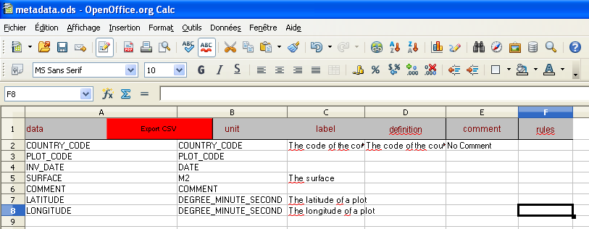

The system is designed to be completely generic and to be able to use any kind of data (if these data respect some conditions …).

The complete system is used on the Eforest project to integrate data, harmonize data and to query it. But it should be possible to use only some parts of the system if we are interested in the query module only.

Metadata structure

Here is the complete conceptual model of the metadata database.

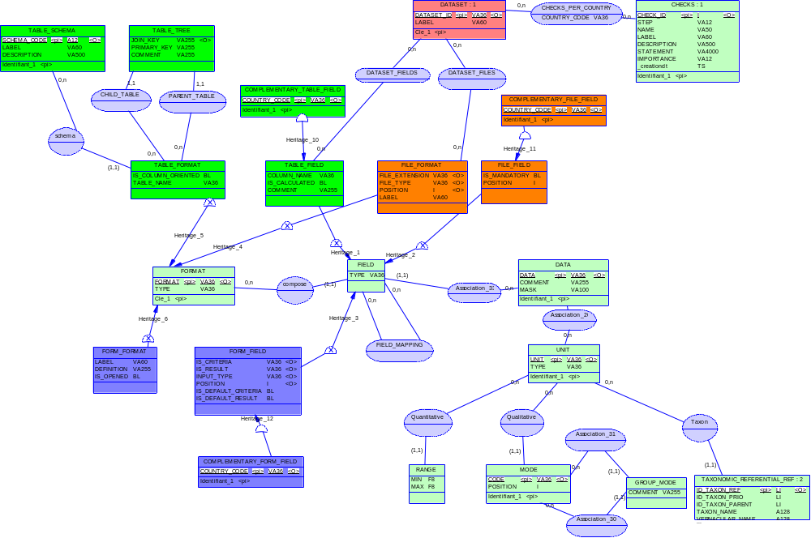

How to define a new data?

A “data” is a logical information, like a “surface” that can be represented as a csv file value, a database table column or a field in a web interface.

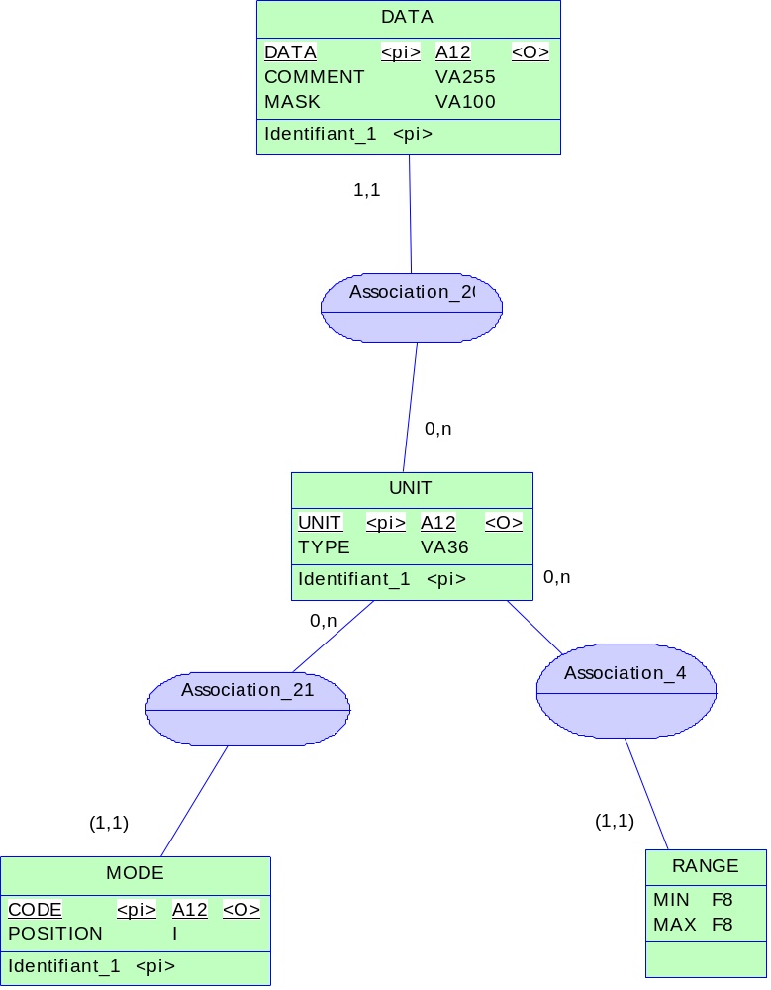

Describe the data

We add a new line in the “data” tab.

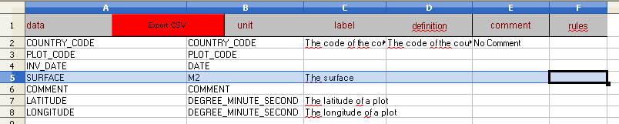

Describe the unit

A data must always have a unit, if the unit of the data doesn’t already exist, we need to add it in the “unit” tab.

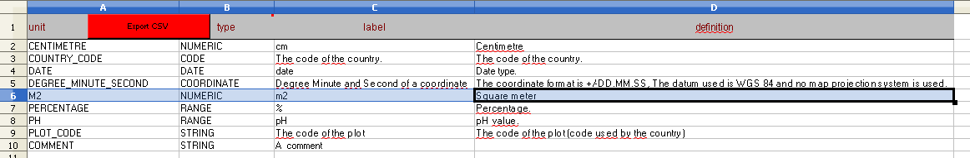

The allowed data types are :

- STRING : A simple string.
- INTEGER : An integer.
- NUMERIC : Any numeric value.
- CODE : A code selected from a list of authorised codes.
- RANGE : A range of numeric values.
- DATE : A date.
- COORDINATE : A geographic position.

Describe the modes

If the unit is of type “CODE”, we must define the list of authorized modes. This is done by filling the “modes” tab.

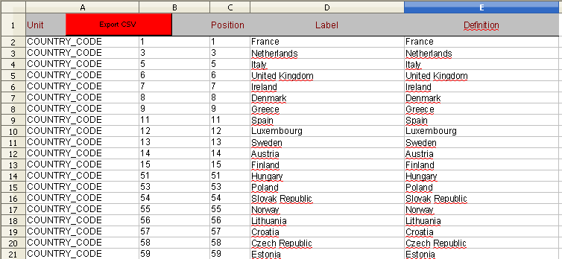

Describe the ranges

If the unit is of type “RANGE”, we must define the range of authorized values. This is done by filling the “range” tab.

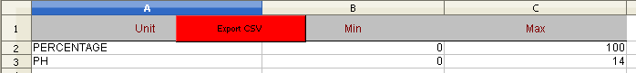

How describe a database format ?

In this step, we describe the available data tables and the list of columns they contain.

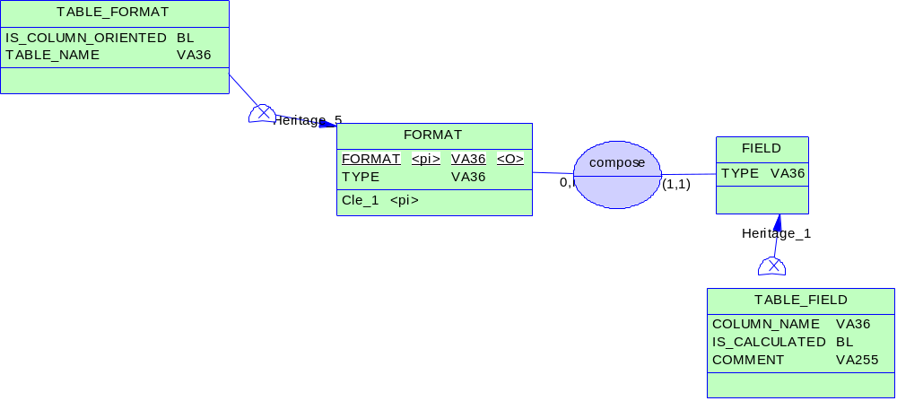

Describe the table

In order to describe a datable table, we edit the content of the “table_format” tab.

The “isColumnOriented” value indicate when the data is stored one value per line.

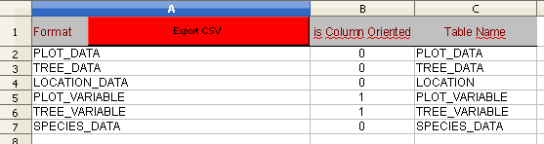

Describe the table fields

Then we need to describe each field of the table in the “table_field” tab. The “isCalculated” flag is used to indicate fields that are not expected when inserting the data because they are calculated by a triggered function.

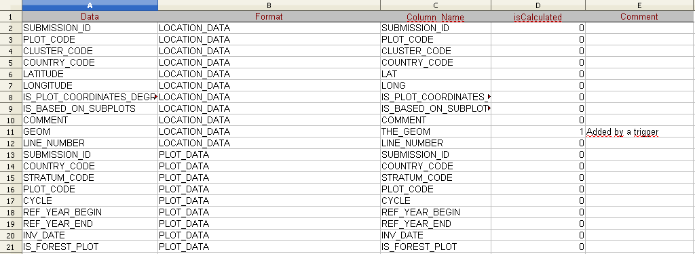

How to describe the tables hierarchy?

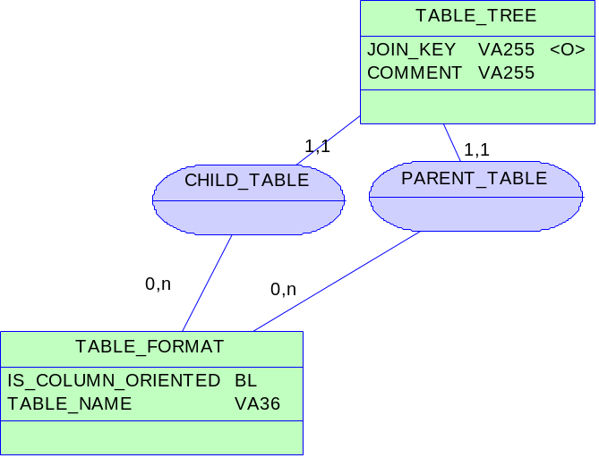

This is needed in order to help the system build SQL requests that are correctly written (to manage the order of the joins between the tables).

We need to describe the relation between the data tables, this is done in the “table_tree” tab.

Each table must be linked to one parent table with the foreign key described in the “join key” value.

The table having the symbol “*” as a parent table is the root of the table hierarchy.

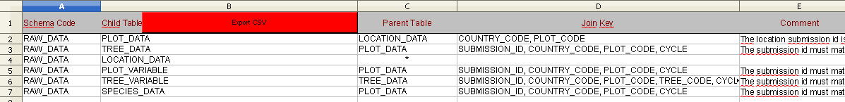

How describe a web-form format ?

In this step, we describe how the data should be displayed on the web site and how we display the corresponding criteria component.

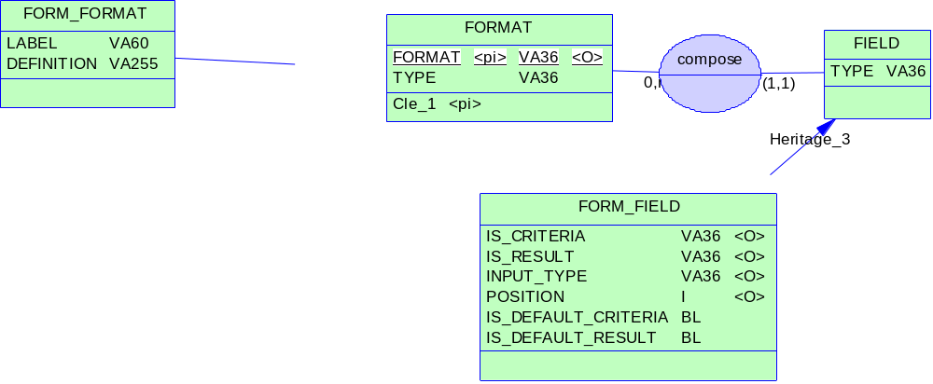

Describe the form

We first describe the logical form in the “form_format” tab.

The label is displayed on the web page as a fieldset legend.

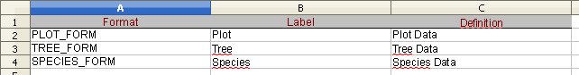

Describe the form fields

Then we describe the fields in the “form_field” tab.

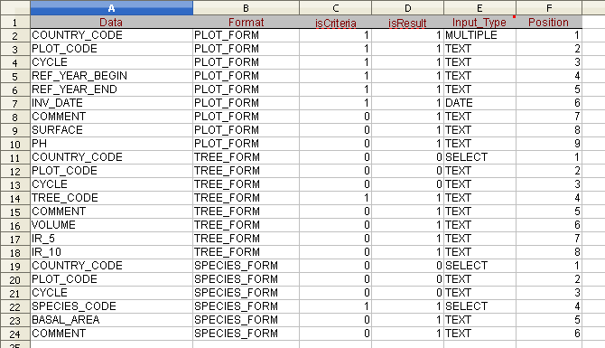

The “isCriteria” flag indicate that the value can be used as a request criteria.
The “isResult” flag indicate that the value can be used as a request result.
The “Input Type” value defines what input type will be displayed to the used.

The allowed input types are :

- TEXT (a simple input text field)
- SELECT (a combobox with one choice)
- DATE (a date picker)
- GEOM (a spatial tool with polygon intersection)
- NUMERIC (a range picker)

Describe the mapping with the database

Once the form is described, we should describe the mapping between the file fields and the database to indicate how are populated the form field.

We fill the “field_mapping” tab (same thing as for the file->database mapping but we change the mapping type value). We cut/paste the first two columns of the “form_field” tab and we describe the source fields (assuming the columns already exist in database, if not see 3).

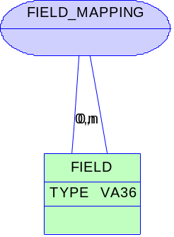

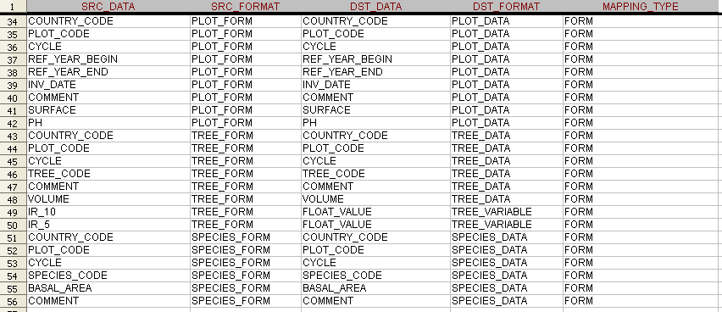

How describe a file format ?

In this step, we describe how the data is stored in the CSV files and how it is transferred into the database.

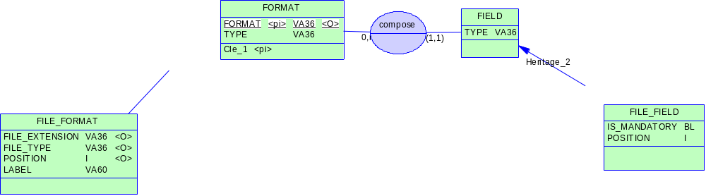

Describe the file

In order to describe a file format, we must first describe the logical file formats in the “file_format” tab.

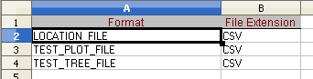

Describe the file fields

Then, we need to describe the content of the files. For this, we fill the “file_field” tab with the name of the expected data (assuming the data is already described, if not see 2).

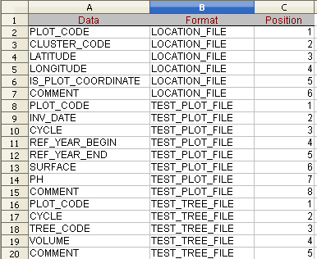

Describe the mapping with the database

Once the file is described, we should describe the mapping between the file fields and the database.

For this, we fill the “field_mapping” tab. We cut/paste the first two columns of the “file_field” tab and we describe the destination fields (assuming the columns already exist in database, if not see 3).

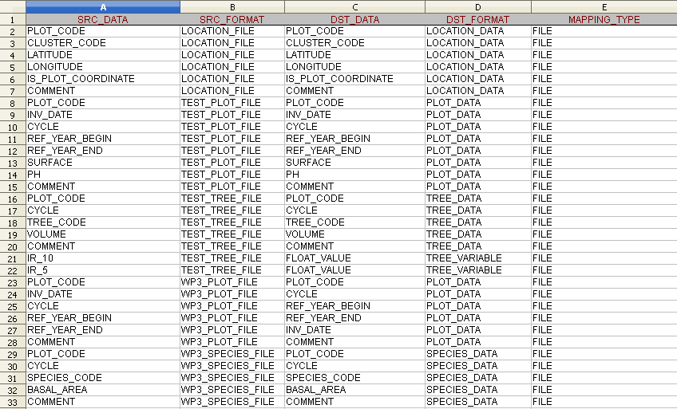

How to create a new dataset?

A dataset is a batch of related data field.

For example, A JRC Request is composed of a set of data files (PLOT and TREE data) with a list of fields that are necessary for the study.

Define the logical dataset

The first step is to give a logical name to the JRC request. To do this, in the “dataset” tab of the metadata spreadsheet, we add a new line (the dataset ID must be unique).

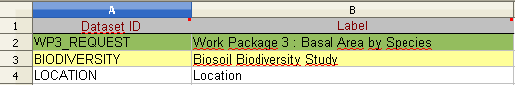

Define the files composing the dataset for data upload

In order to configure the system to allow the upload of files, we must define the link between a dataset and a list of files.

We need to specify the files asked to the user (it can be a single PLOT data file or both a PLOT and a TREE data files). To do this, in the “dataset_files” tab of the metadata spreadsheet, we add one line per file format and we specify a logical name to the file formats.

The file type can be either “PLOT_FILE” or “TREE_FILE”, it is used to match the filenames passed to the servlet with the good format.

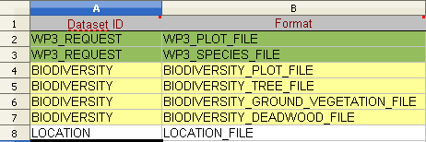

Define the form fields composing the dataset for data querying

In order to configure the system to allow the querying of data, we must define the link between a dataset and a list of data fields.

To do this, in the “dataset_files” tab of the metadata spreadsheet, we add one line per file format and we specify a logical name to the file formats.

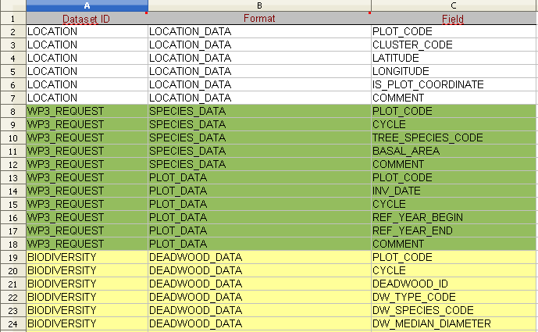

How to define the complementary fields for a given country?

For some countries, we can add some complementary fields that are specific to this country.

The complementary fields are usually stored in some column-oriented tables.

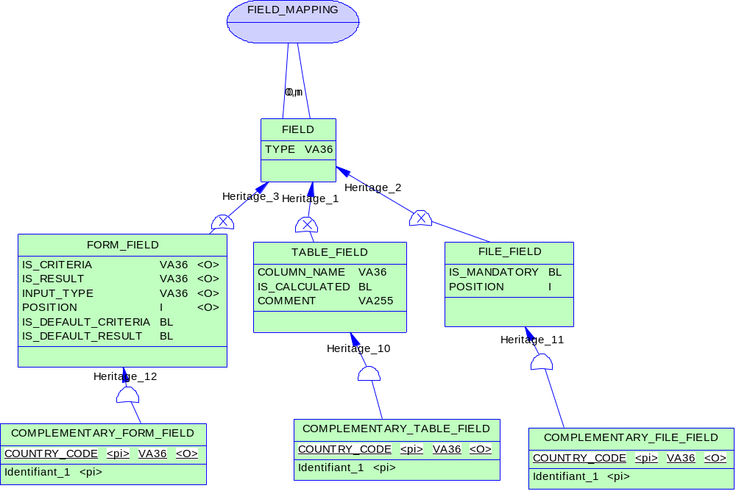

Describe the complementary fields

To add some complementary fields, you should:
- Add the description of the corresponding data (see 3).
- Add the description of the table field.
- For the query module, add the description of the form field.
- For the importation module, add the description of the file field.
- Add the mappings between the different fields.

